Experience:
Experience Tab structure: Ok

Areas of Expertise
Specific skills and competencies
Please add below in the dropping list, remove one time Empathy as it is listed 2 times:
Interpersonal and Emotional Skills:
Problem-solving
Conflict resolution
Communication skills
Empathy
Attention to detail
Team collaboration
Emotional intelligence
Patience
Cultural sensitivity
Adaptability
Organizational and Analytical Skills:
Time management
Multitasking
Critical thinking
Decision-making under pressure
Data interpretation
Record-keeping accuracy
Leadership and Mentorship Skills:
Staff supervision
Training and mentoring
Delegation
Crisis management
Technology and Software Proficiency:
Electronic Health Records (EHR) systems
Medical devices operation
Scheduling software

This below sentence is missing:
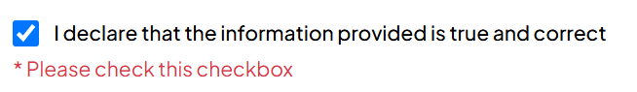

I declare that the information provided is true and correct: It should be mandatory, but once it is ticked, it can stay ticked, no need to ask again to tick for the other changes of the section.

I will check all the otehr functions once we will be able to upload files and save changes, Thank you

